Homework #4

Given the number of web pages N = 3, and the damping parameter d = 0.7. For the two networks shown below, calculate the PageRank of the pages A, B, and C. Links between the pages are shown in the graph itself.

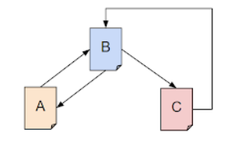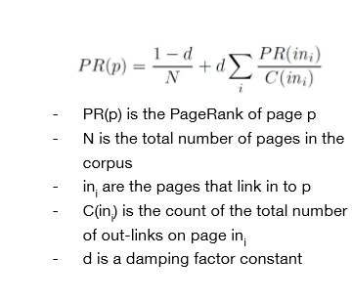

PR(A) = (1 – 0.7) / 3 + 0.7 { PR(B) / 2}

PR(B) = (1 – 0.7) / 3 + 0.7 { PR(A)/1 + PR(C)/1 }

PR(C) = (1 – 0.7) / 3 + 0.7 { PR(B) / 2}

PR(A) = 0.1 + 0.35PR(B)

PR(B) = 0.1 + 0.7PR(A) + 0.7PR(C)

PR(C) = 0.1 + 0.35PR(B)

Solving the equation:

PR(A) = PR(C) = 0.2647058

PR(B) = 0.470588

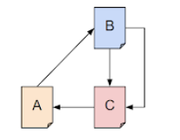

PR(A) = (1 – 0.7) / 3 + 0.7 { PR(C) / 1}

PR(B) = (1 – 0.7) / 3 + 0.7 { PR(A) / 1}

PR(C) = (1 – 0.7) / 3 + 0.7 { PR(B) / 2 + PR(B) / 2 }

PR(A) = 0.1 + 0.7PR(C)

PR(B) = 0.1 + 0.7PR(A)

PR(C) = 0.1 + 0.7PR(B)

Solving equation:

PR(A) = PR(B) + PR(C) = 1/3 = 0.33333..